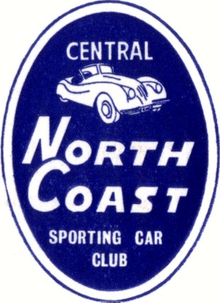 | Wingham Accounting Services  Khanacross  ENTRY FORM |  | OFFICIAL USE ONLY
 |  |  | CLASS | CAR #
CLUB |  | Central North Coast Sporting Car Club
DATE |  | Saturday 31st January 2026
ENTRY FEE |  | $ 65

COMPETITOR (CAR OWNER) |  | DRIVER
Name |  | Name
Address |  | Address
Date of Birth |  | Date of Birth
Phone |  | Phone
Mobile |  | Mobile
Email |  | Email
MA Licence # |  | MA Licence #
Club |  | Club
Member # |  | Member #
Emergency Contact  & Number |  | Emergency Contact  & Number

DESCRIPTION OF CAR
Make | Model | Year | Colour | Body Type | Capacity | 2wd/4wd | Turbo | Class

